Hello All,

Thanks again for checking on data used in this analysis and highlighting any problematic taxonomic ID’s or observations that required changes. Below, I have provided a summary of these corrections.

**Changes to Taxonomy:**

Community data has been run through Jon Bakker’s cleaning code and double-checked for any additional changes that were suggested by Site PI’s. A full list of taxonomic changes is available here, organized by site:

<https://docs.google.com/spreadsheets/d/11hnrH6mU9Tu3NUPqahTT_HXxUb4ZdexrXhhxJioj1sI/edit?usp=sharing>

If I missed anything, please let me know! Note that this list is comprehensive, including species with low frequencies that are filtered out in my analysis pipeline.

**Changes to Model Formulation and Species Filtering Criteria:**

After close inspection of estimated species response that were highlighted as potentially problematic, I have made a few fixes that have (hopefully!) solved these issues. In brief:

1) The model used to estimate responses has been re-worked to better account for repeated observations of plots

2) Species are now filtered to those in >33% of observations, rather than 20%.

For most sites, these changes do not substantially change estimated responses, though the number of statistically significant treatment effects has decreased. Effects are most apparent in sites with large spatial heterogeneity across plots or many infrequent taxa. If interested, I have also included more detail on these changes at the end of this email.

**Updated Results App:**

I have generated an updated version of the Shiny app that accompanied the initial Opt-In – <https://ebatzer.shinyapps.io/NN-Dimensionality>. As I continue to work towards a full draft of this manuscript, please do not hesitate to reach out if there are any additional changes that need addressing.

Best,

Evan

**Optional Modeling Detail:**

*Model Formulation*

Poor estimates of species responses appeared to be common in sites with large plot-level variance in community composition prior to treatment. Rather than include a “block” term in models to address spatial variation in communities, I’ve opted to use a “plot” term to better account for the repeated-measures design of the NutNet experiment.

The new model used to estimate coefficients is as follows:



Where the cover of a given species (Yijk) in a given plot x year combination is estimated as a function of the quantity of nutrients added at that observation (expressed as the number of years of nutrient treatment) while accounting for interannual variation in cover at the site scale, and the initial conditions of each plot. Note that fertilization terms are no longer log-transformed as they were previously – diagnostic plots showed no significant differences between the standard and log-transformed versions of these models, and I think the former is easier to interpret. I would be happy to discuss this in more detail, if interested.

*Species Filtering*

Other issues arose from species that were too infrequent to provide good estimates of treatment response. Typically, these were species that were only consistently present for a small subset of years, either disappearing in all plots after a few years of treatment or recruiting in during later years. Creating a stronger filtering threshold seems to have helped – responses are only estimated for species that are not transient, present in >33% of plot observations.

For Kim:

Hello Kim,

In your previous feedback, you made a couple observations that I wanted to follow up on quickly. In response to the Opt-In outline for this project, you wrote the following:

*Did you run your species data through Jon Bakker’s cleaning code? I ask because we don’t have a ton of Sporobolous heterolepis in many plots at our site, but it is increasing in abundance in a couple. It is a big outlier on the* [*konz.us*](http://konz.us/) *graph, and I wonder if it was a cleaning issue. I’d assume other sites have similar issues.*

Thanks for the suggestion to run data through Jon’s cleaning code. Between this fix and changes to modeling, I think I’ve been able to address your concerns. As you mention, *Sporobolous heterolepis* has very strong plot-level variance in the Konza site:

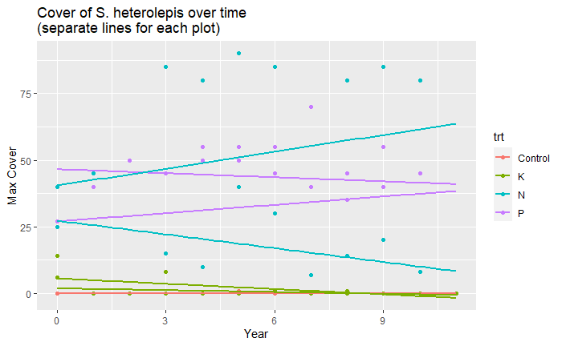

Failure to account for this variance was skewing the N and P coefficients for this species. The updated version seems far more reasonable, with generally much smaller magnitudes of change.

If you have any other questions, please feel free to let me know!

Best,

Evan

For Pedro Daleo:

Hi Pedro,

In your previous feedback, you made a couple observations that I wanted to follow up on quickly. In response to the Opt-In outline for this project, you wrote the following:

*I’m probably missing something but at Marc.ar there are some species that greatly increased cover after fertilization (notably the invader Festuca arundinacea) but estimated N and P responses have negative values. I will check our data just in case, and let you know.*

Looking at my data, I think the (slightly) negative effects of fertilization on *F. arundinacea* are due to a general increasing trend in cover for this species across all treatment types. Visualization of *F. arundinacea* cover over time shows that growth in N and P plots has kept pace with Control communities:

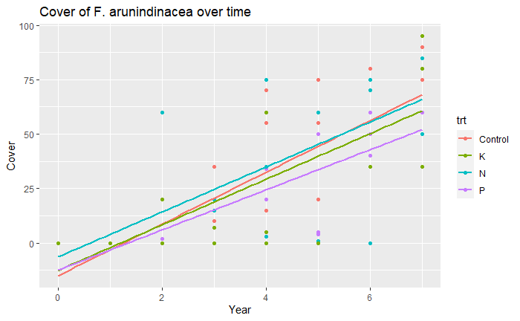

Because this model attempts to estimate fertilization effects from de-trended data, the small net difference between treatment and Control communities estimates a small negative effect. Does this interpretation make sense given what you’ve observed in the field?

If you have any other questions, please feel free to let me know!

Best,

Evan

Christiane Roscher

Hello Christiane,

In your previous feedback, you made a couple observations that I wanted to follow up on quickly. In response to the Opt-In outline for this project, you wrote the following:

*I checked the response of species for the Jena site. I was happy to see that all legumes responded negatively to N addition. I found it interesting to see that one legume (Trifolium repens) responded negatively to P addition, while the other followed the expectation to respond positively to P. I also found the response of most grasses and forbs in line with our field observation, except for Elymus repens. Your app indicated a negative response to Elymus to the addition of single nutrients. I would have expected that this species responded at least positively to N addition.*

Corrections to the initial plot conditions seems to have moved these estimated responses more in line with your predictions; both *Trifolium* species are now estimated to respond positively to P enrichment, while *E. repens* is estimated to respond positively to N enrichment.

If you have any other questions, please feel free to let me know!

Best,

Evan

Johannes Knops:

Hello Johannes,

In your previous feedback, you made a couple observations that I wanted to follow up on quickly. In response to the Opt-In outline for this project, you wrote the following:

*1. When I look at the data from my site (bogong.au) there were quite a lot of responses that changed sign with different nutrients but had a similar quite small magnitude which I think means they will be quite close to the 1-1-1 line? Does this mean that in this analysis this circumstance will come through as responding similarly even though the signs are different (which to me suggest oppositely).*

Directionally different responses are not be assumed to respond similarly in this analysis. However, similarity of responses across all taxa within a site will be more influenced by species with large responses, so these small magnitude effects have proportionally less influence on a site’s overall relationship to the 1:1:1 line.

*2. Overall the responses seemed reasonable although I was surprised by the magnitude of the K response – especially for Craspedia jamesii which is one of the dominants*

Correcting for plot effects seems to have changed this result. K effects are now estimated to be the least impactful at this site, while *C. jamesii* is estimated to respond strongest to P enrichment.

*3. I’m not sure what the taxa erigeron sp. is doing in the data set as the two erigeron species are easily distinguished and I’m pretty sure they have never been lumped. It would be good to check this as it has a high frequency in the dataset. If you send me your data I can cross check with my raw data and sort it out.*

In the raw data, there appears to be a shift that occurs in reporting “Erigeron Sp.” in 2009-2013, before subdividing into the two species from 2014 onwards. In this updated dataset, I’ve lumped these labels together. Attached is a sample of the raw data from the “full-cover” dataset available on the NutNet Dropbox. Are there any addition corrections that need to be made?

*4. microseris sp can be aggregated into microseris lanceolata it is the same species that has had a name change (from sp to lanceolate)*

Correction has been made.

If you have any other questions, please feel free to let me know!

Best,

Evan

Glenda Wardle:

Hello Glenda,

In your previous feedback, you made a couple observations that I wanted to follow up on quickly. In general, I think your sites have been among the most affected by my changes, I think in large part due to variable presence/absence of species at both ethamc.au and ethass.au. In response to the Opt-In outline for this project, you wrote the following:

*The burnt site ethamc.au showed significant response for all three nutrients: N, P, K+ Fraction of variance explained was 0.571.*

This has now changed based on modeling updates – response to P enrichment is now the only significant compositional effect.

*The unburnt site ethass.au was only significant for N and P, but not K. Not sure why. Fraction of variance*

*explained was 0.405, slightly less than for ethamc.au.*

As above, this effect has also changed. N and K effects now seem to be most significant here. This site, in particular, might be hard to generate good estimates for species responses – few taxa appear to be common across years.

*Interesting responses:*

*Ptilous polystachyus had inconsistent responses to nitrogen across both sites - increaser 0.7716*

*in ethamc.au but decreaser -0.1519 in ethass.au*

This species is now filtered out at ethass.au – data seems to show presence only after 2015. I think it’s hard to get an appropriate estimate of response in this case.

*Ephemeral forb Trachymene glaucifolia, has inconsistent responses across both nutrient type and site.*

This species is now filtered out at both sites.

*Triodia basedowii is a strong decreaser with addition of N and P for both sites, and a decreaser*

*under K addition at ethass.au but opposite response of increaser at ethamc.au.*

Triodia is now estimated to increase with all nutrients at ethass.au and decrease at ethamc.au.

*Euphorbia tannensis does not do well with any of the nutrient additions, strong decreaser response*

*to N, P, K in both sites. Therefore, one could think of its presence in any plot as an indicator of*

*relatively low nutrient status.*

A good observation, though unfortunately, I’m concerned that my approach may not capture the importance of presence as an indicator. This species has also been filtered out with new criteria.